CoreLogic (ADE)

AuthoMail Registration Workflow Documentation

Version Control

Version | Date | Author | Change Description
1.0 | 11.26.2018 | Robin McFarlane | First Draft
1.1 | 12.12.2018 | Robin McFarlane | 2ND Draft
1.2 | 12.21.2018 | Robin McFarlane | 3rd Draft
1.3 | 01.23.2020 | Geordina Fernandez | 4th Draft

For Approval

Version | Date | Author | Change Description

User Registration Guide:

Go To Authomail URL
https://authomail.corelogic.com/Account/Login?ReturnUrl=%2F
Select Register:
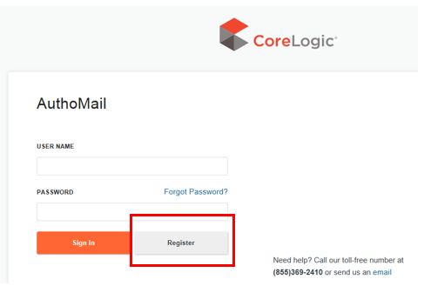
Add New Users Email Address, Click Next :

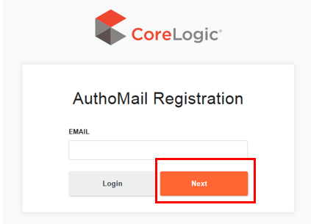

Complete New Users Contact Information, Create Default Password for New User
**must include upper & lowercase letters, number, and special character**

Click Register:
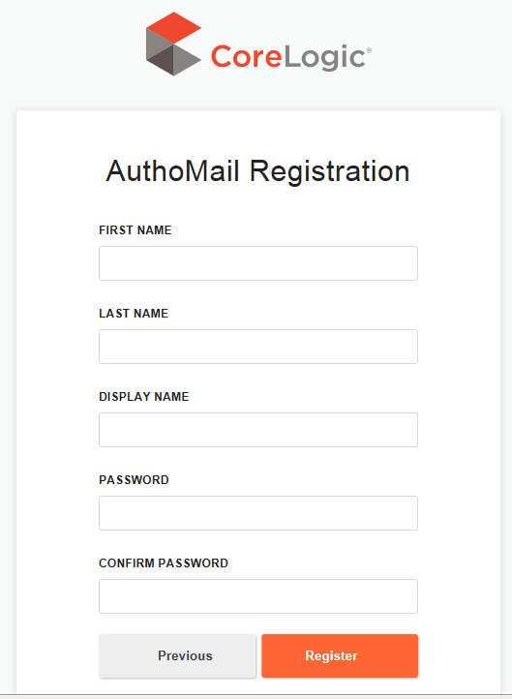

After Registered a Thank you email will appear, Next Steps SEE FLOW CHART BELOW
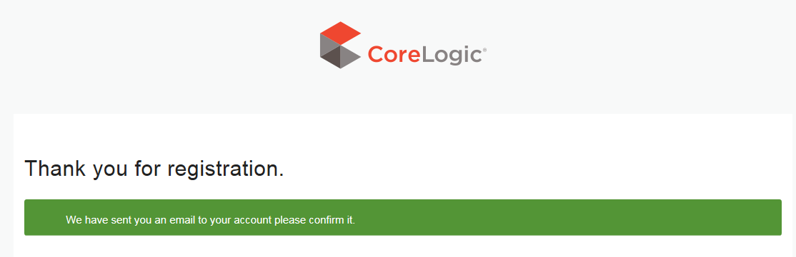
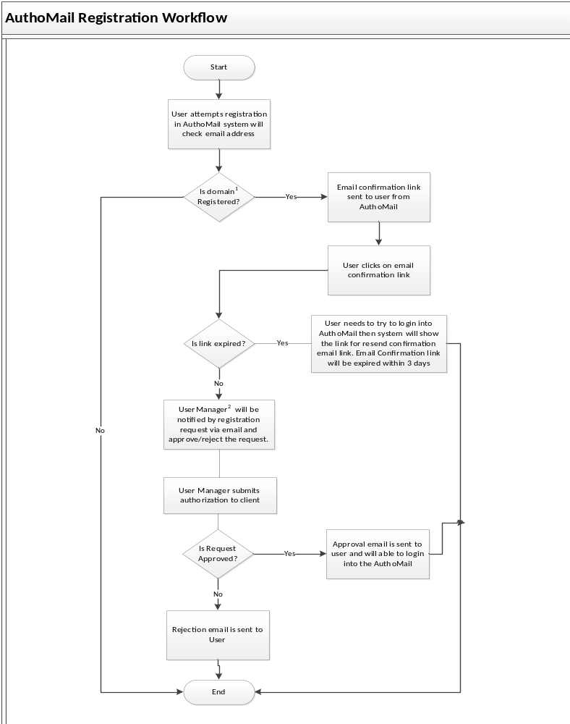Authomail User Acceptance Specifics:

- If the respective domain(s) are not registered in the AuthoMail system, then user with “outside” domain email address is not allowed to register.
  - For example, if, domain “corelogic.com” is not registered in AuthoMail and a user attempts to register with email address “user@corelogic.com” in AuthoMail then system will immediately restrict user, denying user the ability to register.
  - Authomail is a public site, with CoreLogic Information Security guidelines that can be viewed and accessed off network. However, user access is reserved only to configured client domain and authorized users (internal/client). e.g. corelogic.com etc.

- CoreLogic User Managers are spavan@corelogic.com, brpatel@corelogic.com, geofernandez@corelogic.com

- User can only login into the system once “User Manager” has approved access request.

- Once a client user request(s) has been received by CoreLogic, A CL User will send a validation email to client to ensure the client user is to be added and / or denied.

  - Note: All users have the same level of access for the Authomail tool.
  - Note: The User will have 3 days to verify their information and register for the site before the verification link expires.

- All denial requests for client users must be forwarded by client designated “Account Manager”. After CL User Manager will send an immediate request to have the client user removed/purged from Authomail Tool – Requesting access.

  - Denied Users will be placed on a “User Removal List” to ensure user(s) cannot be added for future access to the tool. Published on Monthly “Vendor Scorecard”.

- List of clients – users will be reflected in Monthly “Vendor Scorecard” distribution PPT for monthly review.

